**Setup or Configure REST Assured**

**1. Create a Maven project in eclipse**

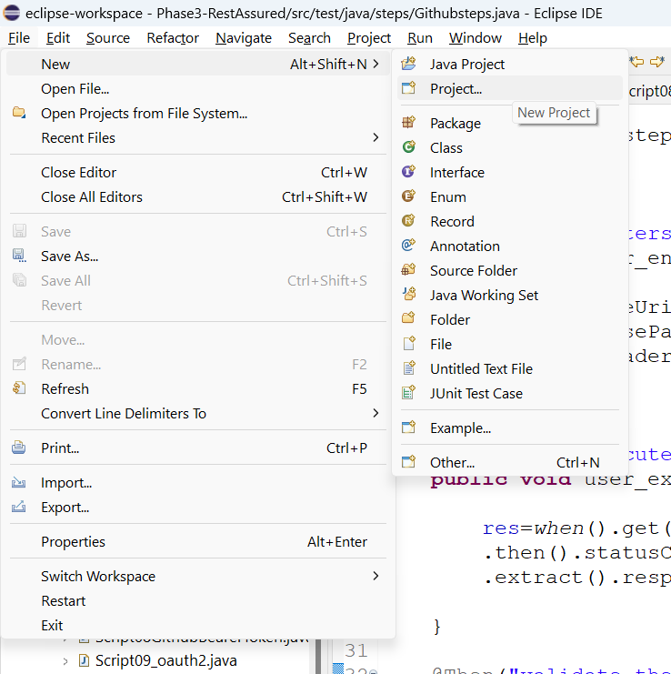

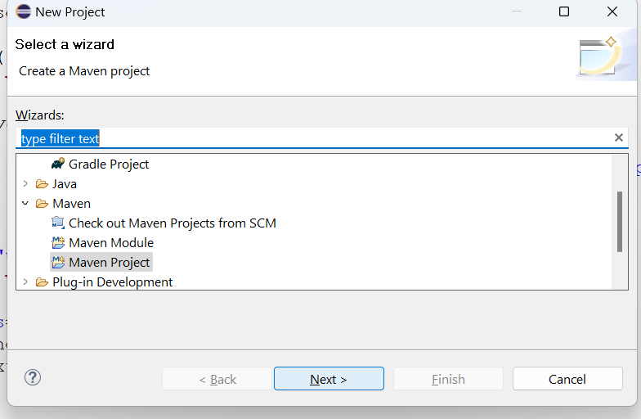

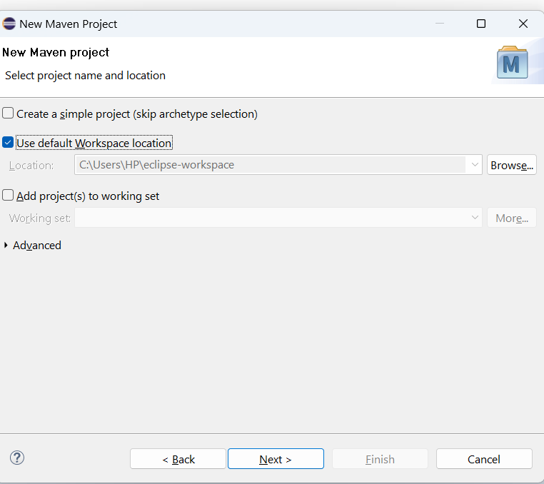

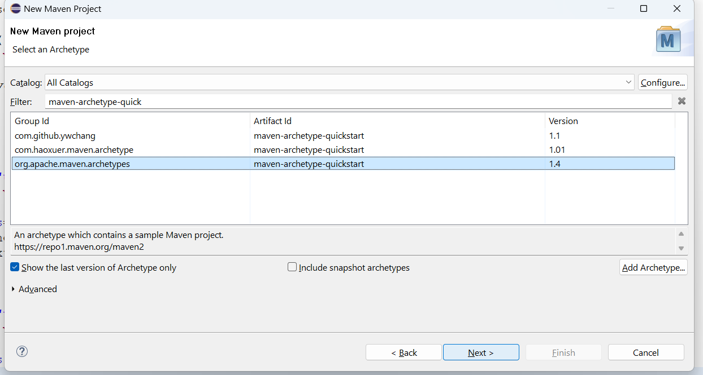

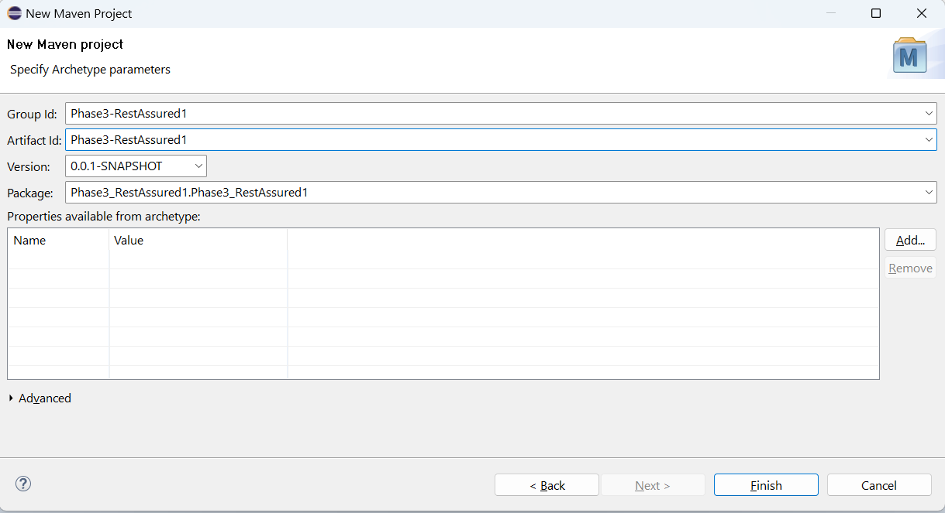

**2. Add required dependencies to pom.xml**

<dependencies>

<!-- https://mvnrepository.com/artifact/io.rest-assured/rest-assured -->

<dependency>

<groupId>io.rest-assured</groupId>

<artifactId>rest-assured</artifactId>

<version>5.3.0</version>

<scope>test</scope>

</dependency>

<!-- https://mvnrepository.com/artifact/io.rest-assured/rest-assured-common -->

<dependency>

<groupId>io.rest-assured</groupId>

<artifactId>rest-assured-common</artifactId>

<version>5.3.0</version>

</dependency>

<!-- https://mvnrepository.com/artifact/io.rest-assured/rest-assured-all -->

<dependency>

<groupId>io.rest-assured</groupId>

<artifactId>rest-assured-all</artifactId>

<version>5.3.0</version>

<scope>test</scope>

</dependency>

<!-- https://mvnrepository.com/artifact/io.rest-assured/json-path -->

<dependency>

<groupId>io.rest-assured</groupId>

<artifactId>json-path</artifactId>

<version>5.3.0</version>

<scope>test</scope>

</dependency>

<!-- https://mvnrepository.com/artifact/org.json/json -->

<dependency>

<groupId>org.json</groupId>

<artifactId>json</artifactId>

<version>20180813</version>

</dependency>

<!-- https://mvnrepository.com/artifact/org.hamcrest/hamcrest -->

<dependency>

<groupId>org.hamcrest</groupId>

<artifactId>hamcrest</artifactId>

<version>2.2</version>

<scope>test</scope>

</dependency>

<!-- https://mvnrepository.com/artifact/com.fasterxml.jackson.core/jackson-databind -->

<dependency>

<groupId>com.fasterxml.jackson.core</groupId>

<artifactId>jackson-databind</artifactId>

<version>2.15.2</version>

</dependency>

<!-- https://mvnrepository.com/artifact/org.testng/testng -->

<dependency>

<groupId>org.testng</groupId>

<artifactId>testng</artifactId>

<version>7.7.1</version>

<scope>test</scope>

</dependency>

<dependency>

<groupId>org.junit.jupiter</groupId>

<artifactId>junit-jupiter-api</artifactId>

<version>5.9.3</version>

<scope>test</scope>

</dependency>

<!-- https://mvnrepository.com/artifact/io.cucumber/cucumber-java -->

<dependency>

<groupId>io.cucumber</groupId>

<artifactId>cucumber-java</artifactId>

<version>7.10.1</version>

</dependency>

<!-- https://mvnrepository.com/artifact/io.cucumber/cucumber-java -->

<dependency>

<groupId>io.cucumber</groupId>

<artifactId>cucumber-junit</artifactId>

<version>7.10.1</version>

<scope>test</scope>

</dependency>

<!-- https://mvnrepository.com/artifact/io.cucumber/cucumber-java -->

<dependency>

<groupId>io.cucumber</groupId>

<artifactId>cucumber-core</artifactId>

<version>7.10.1</version>

</dependency>

<dependency>

<groupId>org.seleniumhq.selenium</groupId>

<artifactId>selenium-java</artifactId>

<version>4.11.0</version>

</dependency>

<!-- https://mvnrepository.com/artifact/io.github.bonigarcia/webdrivermanager -->

<dependency>

<groupId>io.github.bonigarcia</groupId>

<artifactId>webdrivermanager</artifactId>

<version>5.4.1</version>

</dependency>

</dependencies>